Caleb Javier
Adrianna Holden-Gouveia
Linux Administration
12 October 2025

Documentation: Continued Server Setup
This documentation will more deeply explore the two installed distributions (CentOS and Debian) and how to navigate them to perform updates and installations.

Repositories
- Checking currently installed repositories on a CentOS server
  - Being a Red Hat Enterprise system, CentOS utilizes a specific command known as “dnf” to display to the user its repo list, which contains installed software. By adding “all” to the command, the user can see both enabled and disabled repositories. The command uses the argument “repolist” and is entered as such:
sudo dnf repolist all
which will return:
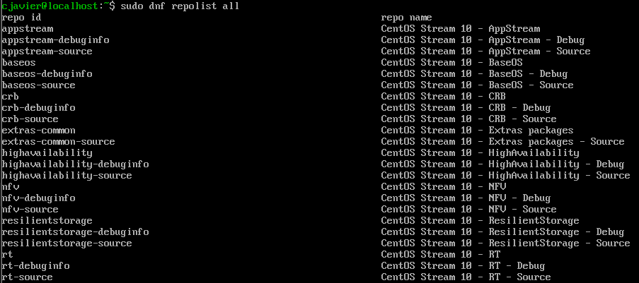
  - To install a repository on CentOS, the dnf command will access the configuration manager, which can invoke an “add repo” command that identifies repositories by URL or ID. Simply “install” can also be used. As an example, the following command is used to install the Extra Packages (EPEL) repo:
sudo dnf install epel-release
which begins the installation process:
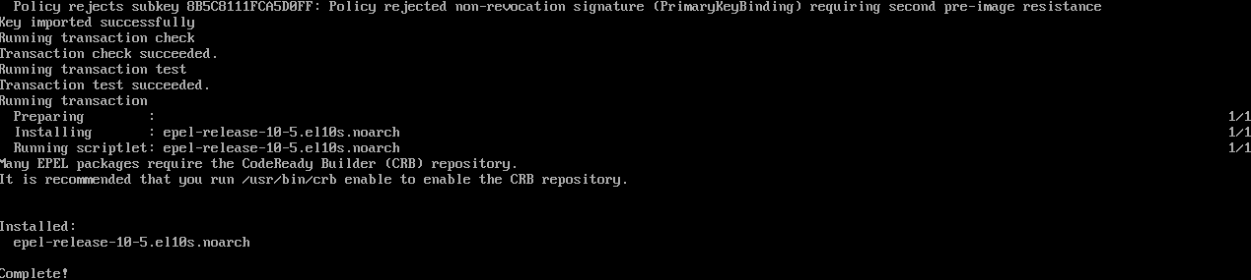
- Checking currently installed repositories on a Debian server
  - To view a list of currently installed repositories, you can use grep on files that contain them. One of the main files that contain this list is located at /etc/apt/sorucest.list. The command below will return a list of all installed repositories while suppressing comments to prevent them from crowding the screen. The provided argument ensures that lines returned by the grep command will not include those that start with the “#” character, which indicates comments.
grep ^[^#] /etc/apt/sources.list
will return:
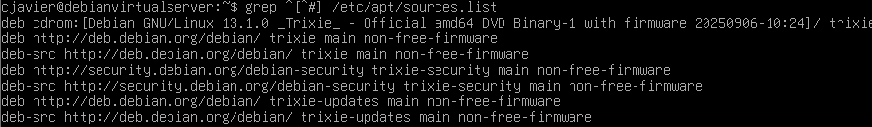

  - To install a repository on a Debian server, the user normally utilizes an “apt” command. It appears however that there has been a bit of a setback as Debian 13, or Trixie, is still in testing and has had the command “apt-add-repository” removed. In this case, the repository will instead be manually added from the official Debian mirror with a “deb line”, using the “nano” text editor. To use it, use nano and navigate to the path of the file to be edited.
sudo nano /etc/apt/sources.list
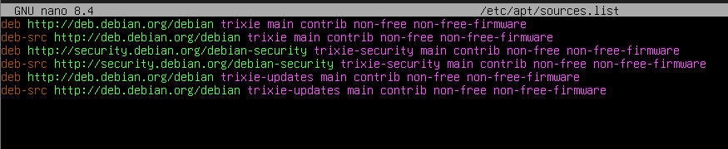
The lines will be added, saved using Ctrl + O > Enter, then the editor will be exited with Ctrl X.
In this case, the popular and safe repo “Backports” will be added, and this can be verified by using grep to scan the sources.list file.

Packages
- Installing packages on a CentOS server
- The dnf command will be used to invoke the install command, through which packages can be added via URL or package ID. As an example, Tmux will be installed to test functionality. As the ID is simply tmux, the command will be:
sudo dnf install tmux
which displays this process:
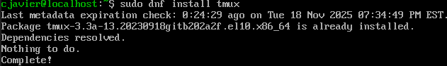
As tmux is already installed with CentOS Stream 10, no installation takes place. It can be checked with dnf list installed tmux to get:
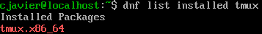
- For the next package, fail2ban, the process is the same, and because EPEL is already installed, there will be no issue when using the command:

sudo dnf install fail2ban
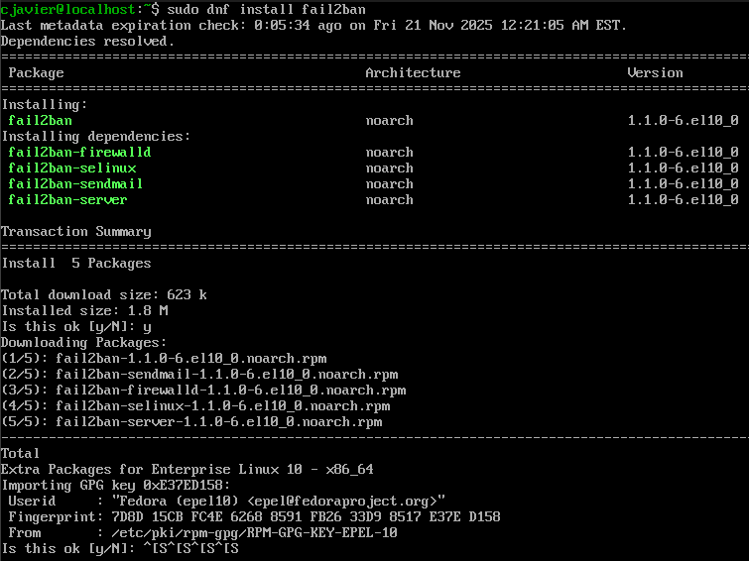
At this point, it is successfully installed and must be run. The status of the fail2ban service can also be checked. This is done with the following two commands, which use the systemctl (system control) to access and manipulate services within the system.

sudo systemctl start fail2ban
sudo systemctl status fail2ban
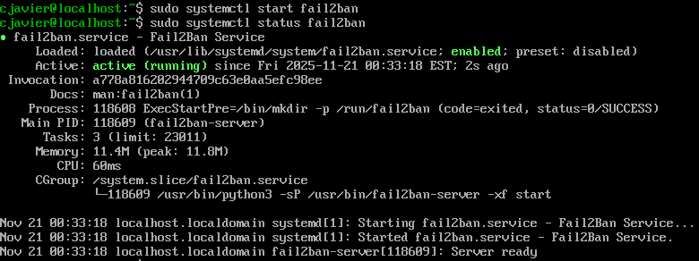
- Next, install emacs using the same formula:
sudo dnf install emacs
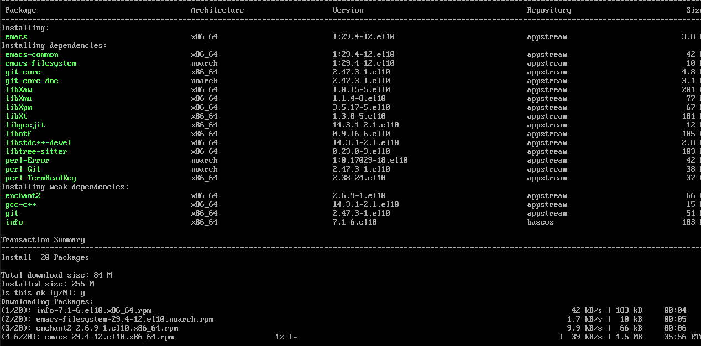
Which should finalize here:
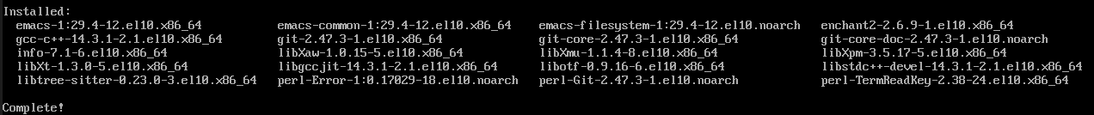
- Installing packages on a Debian server
- Similarly, we will begin by installing the same list of packages on our Debian server. Using the same apt tool as we would if we were able to install repositories, we can install packages via their ID name. The first is as follows:
sudo apt install tmux
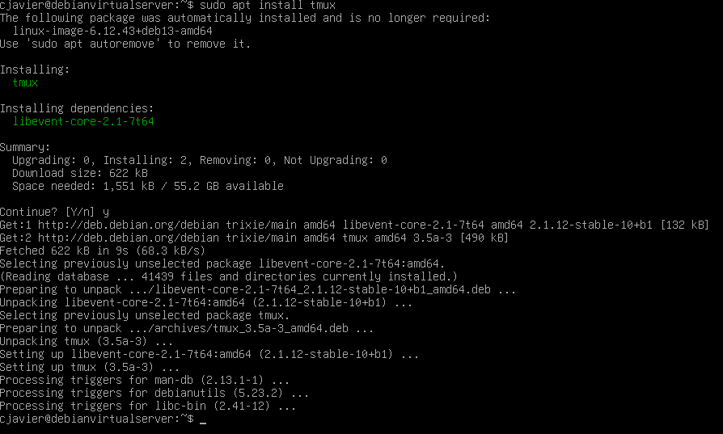
In order to verify that it has been installed, call its version via the command
tmux -V
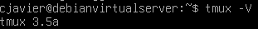

- Continuing with emacs, in a similar fashion:
sudo apt install emacs
The process is lengthy as lots of information is downloaded, but you can verify installation again by invoking the “which” command, which will locate the actual executable file.

which emacs
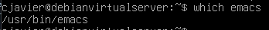
- Finally, do the same with fail2ban.

sudo apt install fail2ban
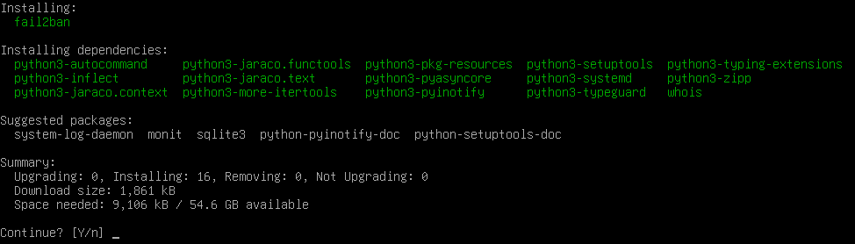
Fail2ban’s service must also be started to begin functioning properly. This can be done using this command:
sudo systemctl enable –now fail2ban
and can be checked using
sudo systemctl status fail2ban
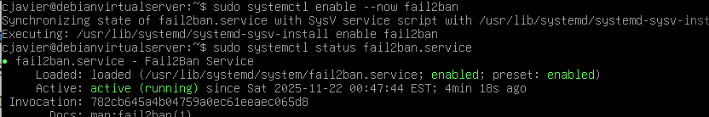

- Installing extra packages
  - For CentOS
We will install extra software to continue testing.
sudo dnf install cowsay
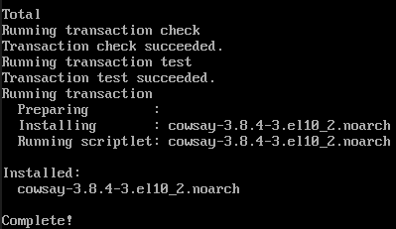
This can be tested simply by using the command “cowsay” and adding text.
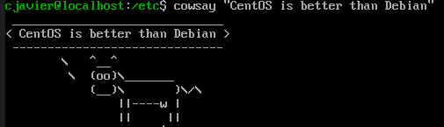
Next, it appears that CentOS stream 10 does not directly support the program lolcat, so we will attempt to install “Ruby”, which allows us to install lolcat as a package.
To install ruby, use the package manager as normal.
sudo dnf install ruby
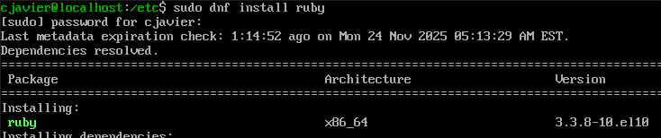
Once complete, we can install lolcat directly from the internet using the wget (web get) tool, from this URL using this command:
sudo wget https://github.com/busyloop/lolcat/archive/master.zip
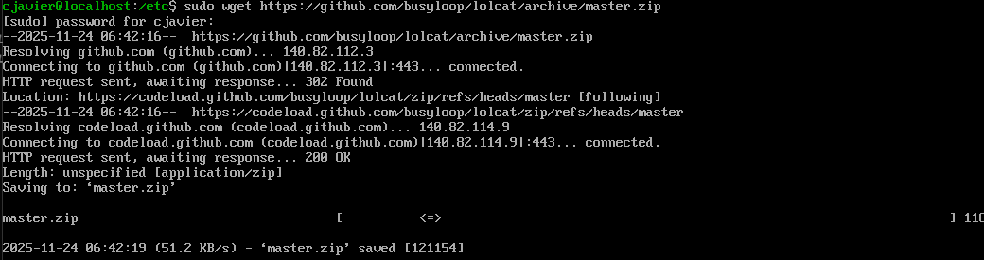
After obtaining this zip file, it must be decompressed or “unzipped”, using the unzip command.
sudo unzip master.zip (do not forget to use sudo or become super user).
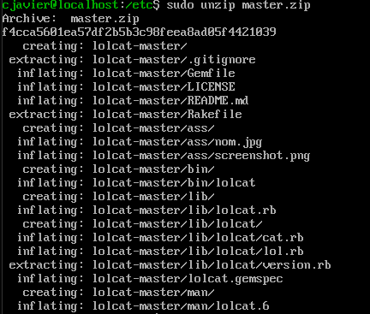
Now that lolcat is present on the machine, we will use the ruby package manager, gem, instead of dnf, to install lolcat.
sudo gem install lolcat
This is not working, could not find workaround.

  - For Debian
Similarly, install cowsay first:
sudo apt install cowsay
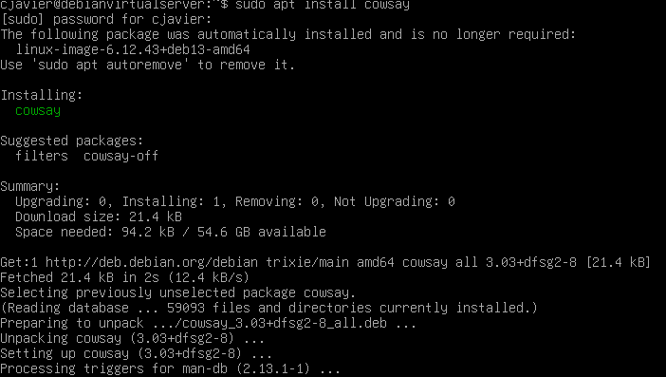
And to test, use in the same way as above:
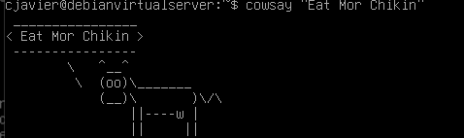
Next,
sudo apt install lolcat
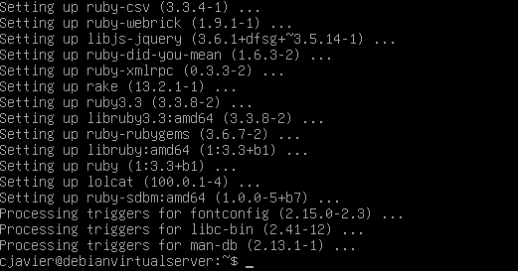
- Updating VI to vim
  - To install vim on both machines, install the vim package in the same way as other software.
sudo apt install vim
sudo dnf install vim
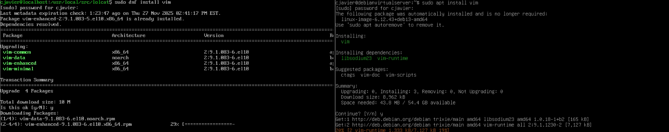
Note that vim is already installed on CentOS stream 10 and it only prompts to upgrade already installed vim packages.
- Using vim
  - Create new files using the touch command.
touch vim1.txt
  - For both, use vim and then the name of the desired file to edit:
vim vim1.txt
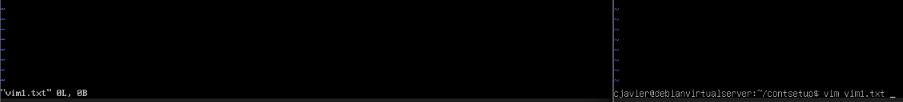
(right is inside the file, left is the command)
  - Simple commands:
    - The user can navigate the file’s lines with the arrow keys
    - Can press Esc to return to main mode
    - Can press the I key to insert text where they would like
    - Can press the X key to delete text where they would like
    - Can save changes made by typing :wq and then pressing Enter.
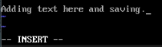
:wq <ENTER>
